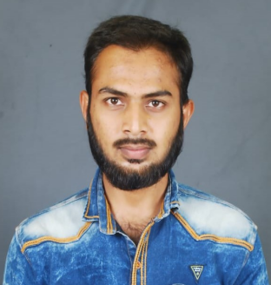

EDUCATION

**Mohammed Qutubuddin Zafar**

Full Stack Developer

   

[Linkedin](https://www.linkedin.com/in/mohammed-zafar-36a94612b/) [Gmail](mailto:qutubuddinzafar2616118@gmail.com) [Github](https://github.com/zafar26) [Portfolio](https://qutubuddinzafar.netlify.com" \o "portfolio)

PROJECTS

PROFILE

Highly talented individual with strong analytical skills desires to work as a Full Stack Developer and Responsible for creating web applications and managing database.

**[Bus Reservation](https://github.com/zafar26/bussbooking)**

Web app to book bus seats

Flask, Python, SQLite3, HTML and CSS.

**[Javascript Tutorial](https://github.com/zafar26/technical)**

Static Web Page to learn javascript.

HTML, CSS.

**[Masjid-app](https://github.com/zafar26/masjid)**

Web App where we can view total income and expenditure.

Backend: Flask, Python, postgreSQL, sqlalchemy ORM.

1. **Web Development** using diffrent languages and stacks.
2. **Programming Languages** C, Python, Javascript.
3. **HTML, CSS** and Bootstrap.
4. **Python** using Flask.
5. **Javascript** using React, ES6, JQuery.
6. **SQL, ORM’S** using PostgreSQL, SQLite3, sqlalchemy, Flask-Marshmallow.
7. **Tools** github, slack, vscode.
8. **Languages** English, Hindi

SKILLS

**Name**

Mohammed Qutubuddin Zafar

**Address**

H-no:3-55,manakondur, karimnagar, telangana. 505469

**Phone**

+918686842949

**Email**

qutubuddinzafar2616118@mail.com

* **CoderHive Edu Tech LLP**

Full Stack Development Program

2019.

* **Jyothishmathi Institute Of Technological Sciences**

Engineering

2016 - 2019.

* **Jyothishmathi Institute Of Technological Sciences**

Diploma (Polytechnic)

2013 - 2016.

* **Huda High School**

SSC (10th standard)

2013

INFO